**Appendix A: Data Inputs for the inVEST Coastal Vulnerability Model**

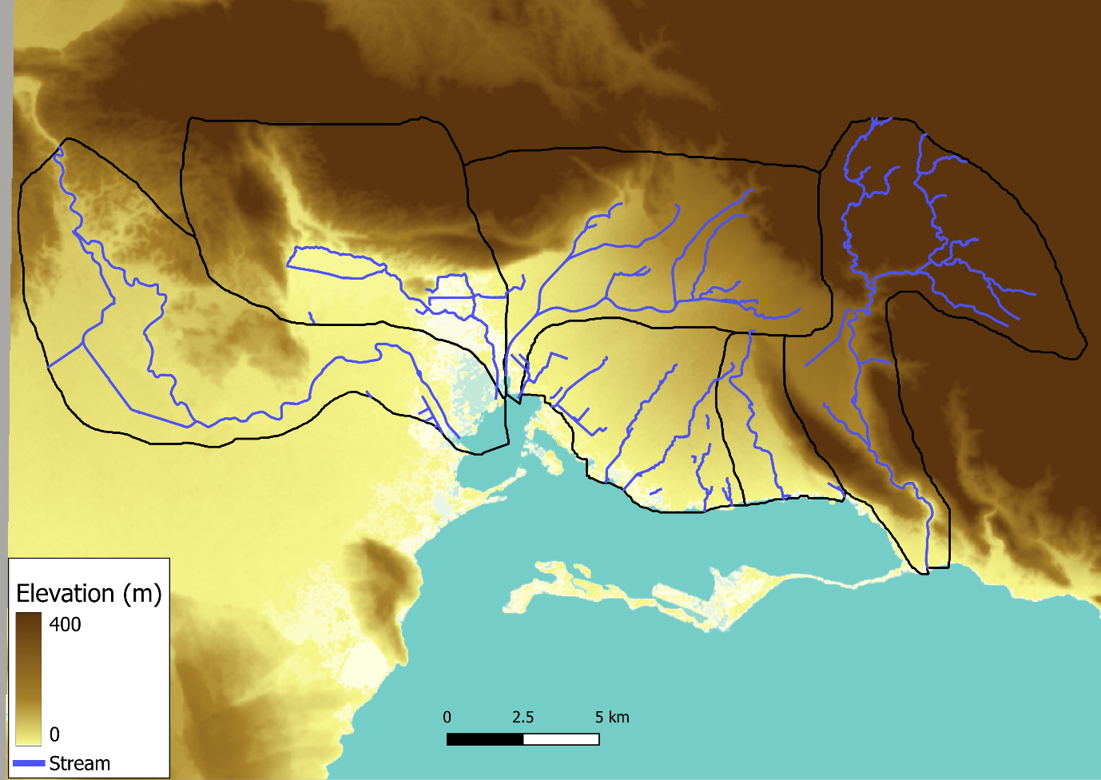

**Figure A1.** Digital Elevation Model for the studied area extracted from the Shuttle Radar Topography Mission [105]. The six studied catchments are delineated in black with blue lines representing the streams and gullies sourced from OpenStreetMap.

**Figure A2.** Shoreline geomorphology classification of the studied area sourced from Allen Coral Atlas [124]

**Figure A3.** Distribution of coastal habitats across the studied area. Coral and sea grass distribution sourced from Allen Coral Atlas []

Sensitivity Analysis of Geomorphology Ranks

As shown in Figure A4, the coastal exposure index does not significantly change using a geomorphology rank of 3, as used in this study and suggested by Silver et al. [40] or 1, as suggested by Ai et al. [41]. The only visible differences are found in the Palisadoes road between NMI and the mainland and for some segments along the western side of the harbour shipping channel. In the first case, the difference is not significant as the hotspot analysis (Figure 5) reveals how exposure along that segment of the Palisadoes is not significant. Regarding the shipping channel, the difference is observed in unpopulated areas of coastline hosting high cliffs, so the difference in exposure does not have any impact on the local population or assets. In contrast, the same Coastal Exposure Index is found in all the key areas of high risk, including Kingston downtown, KCT and Port Royal (Figure A4).

**Figure A4.** Coastal exposure index under current SLR calculated with bedrock exposure ranks of a) 3 (as for Figure 4) and b) 1

SCS Curve-Number Method for Runoff Calculation

The inVEST UFRM model uses the SCS-Curve Number method to estimate generated and retained runoff in the studied area. The SCS-CN method is a well-established method in flood exposure assessments, and it provides an estimate of runoff generation (and retention) based on land cover and hydrologic soil characteristics [126]. At every point in the studied area, the soil runoff retention capacity is estimated as a function of the Curve Number, an empirical parameter relating the land cover to the hydrologic soil type. Curve numbers used in this study are reported in table A1. Land cover data were extracted from the ESA World Cover database at 10 m resolution [73], while the hydrologic soil groups were sourced from the HYSOG 250 m gridded dataset [127] (Figures A1 and A2). In this classification, each soil type (A, B, C and D) represents a class of increasing runoff potential based on the soil saturated hydraulic conductivity and depth.

**Table A1.** Curve Numbers of the land covers relevant for this study for each hydrologic soil type. A higher number represents a higher runoff generation potential [46].

|  |  |  |  |  |  |
| --- | --- | --- | --- | --- | --- |
| Land cover | Hydrologic soil type | | | | Source |
| A | B | C | D |
| Tree | 36 | 60 | 73 | 79 | Quagliolo et al. (2021) |
| Shrubland (wood grass combination) | 43 | 65 | 76 | 82 | Quagliolo et al. (2021) |
| Grassland (fair condition grass 50-75%) | 49 | 69 | 79 | 84 | Quagliolo et al. (2021) |
| Cropland (row crop) | 64 | 75 | 82 | 85 | Quagliolo et al. (2021) |
| Built up (dense urban) | 98 | 98 | 98 | 98 | Quagliolo et al. (2021) |
| Bare | 68 | 79 | 86 | 89 | Quagliolo et al. (2021) |
| Water body | 98 | 98 | 98 | 98 | Quagliolo et al. (2021) |
| Wetland | 72 | 81 | 88 | 91 | Quijano et al. (2015) |
| Mangroves | 98 | 98 | 98 | 98 | Quijano et al. (2015) |

Data Inputs for the inVEST UFRM Model

Land cover classes (Figure A5) and soil hydrologic type for the studied area (Figure A6).

**Figure A5.** Land cover classes for the studied area sourced from the ESA World Cover database [73].

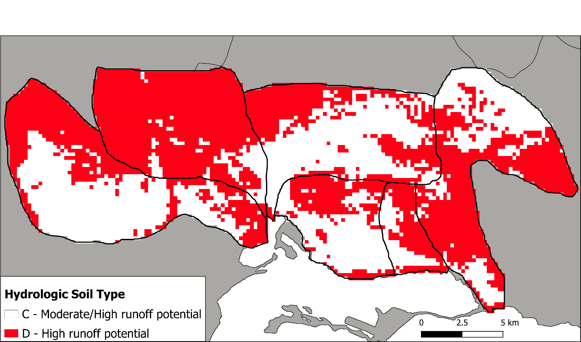

**Figure A6.** Hydrologic soil type in the studied area sourced from the HYSOG 250 m dataset [127].

Runoff Generation

Figure A7 shows the runoff generation (mm/10 m2) calculated with inVEST UFRM in the study area.

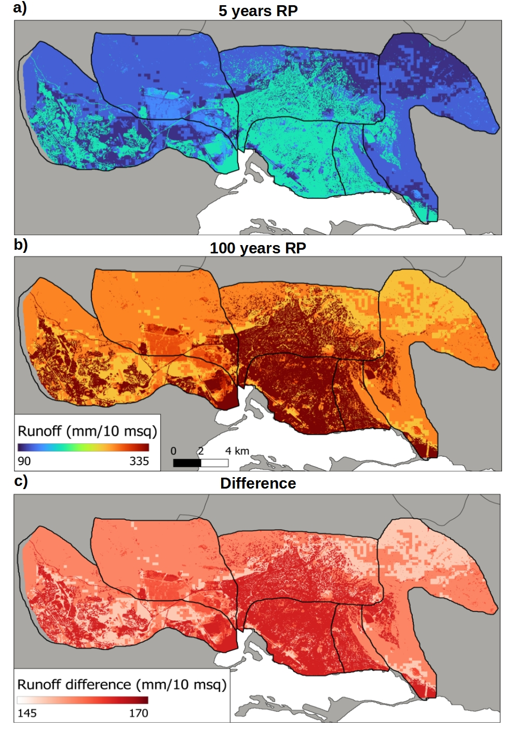

**Figure A7.** Runoff generation (mm/10 m2) for a) 5-year RP storm (178 mm rainfall/24 h) and b) 100-year RP storm (342 mm rainfall/24 h), with the difference between the two scenarios shown in c).

**Appendix B:** **Ethics Approval Form**

